Stay Connected Tips
- Touch base with fellow teammates
- Share your favourite dance moves
- Call your family, friends, fellow athletes
Stay Active Tips
- Take part in SOO’s weekly wellness challenges
- Watch workout videos from your fellow athletes
- Learn how to do Yoga & do some with family

Stay Positive Tips
- Take breaks from screen time
- Write down 3 things you are grateful for
- Share photos of things that make you smile

Stay Informed Tips
- Check out the stay informed section on the Special Olympics Ontario website
www.specialolympicsontario.com
TIME | MON. | TUES. | WED. | THURS. | FRI. | SAT/SUN
7:00 –  8:00 | Wake up. Rise and Shine!
8:00 –
9:00
9:00 - 10:00
10:00  -  11:00 |  | Go for a 30  minute walk
11:00  -  12:00 |  |  |  |  | Watch From the  Stands Interview
12:00
-
1:00
1:00  -  2:00 |  |  | 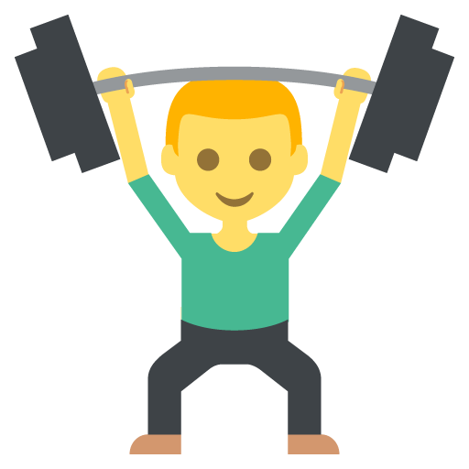  Follow a Wellness Wednesday  Workout
2:00  -  3:00 |  |  |  |  | Join an online mindfulness  Session
3:00
-
4:00

GENERAL NOTES
Stay Informed Tips
Stay Positive Tips
Stay Active Tips

