Hello Everyone!

Here is the link for our Netflix Party - tonight at (Time)pm!  Just click the link below, then click the "NP" button next to the address bar and you should automatically join the party.

If you need the instructions on installing Netflix Party - I have included again below.

Thanks everyone!  Make sure to comment once you're on so we know you're there!

**The Winning Movie is……. (Movie Title)**

(Insert link to Netflix Party)

**Instructions to put Netflix Party on your Computer**

1.  Ensure Google Chrome is installed on your laptop or desktop.

2.  You will need to install the Netflix Party Extension.  Use this link and click on "Add to Chrome" in the top RH corner of the screen (see pic below).

<https://chrome.google.com/webstore/detail/netflix-party/oocalimimngaihdkbihfgmpkcpnmlaoa?hl=en>

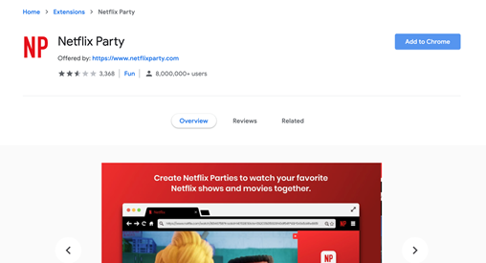

3. Another box will pop up asking you "Add Netflix Party?"  Click "Add Extension" as per pic below.

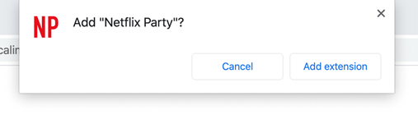

4.  You should now see a "NP" to the right of your search bar at the top of Chrome.  You're good!

5.  Then go to the top of this email and click on the link for the movie provided!

See you tonight!