Hello Special Olympics (Community)!

We will host a Netflix Party this (Date) at (Time)!

You must have a subscription to Netflix to join the party AND Netflix Parties can play only using Chrome on a Laptop or Desktop PC or Mac (you will need to download an extension - instructions below)

What YOU need to do:

1.  Vote on which movie you want - send me an email or do the poll on our Facebook Account

* (List Movie Options)

2.  Ensure Google Chrome is installed on your laptop or desktop.

3.  You will need to install the Netflix Party Extension.  Use this link and click on "Add to Chrome" in the top RH corner of the screen (see pic below).

<https://chrome.google.com/webstore/detail/netflix-party/oocalimimngaihdkbihfgmpkcpnmlaoa?hl=en>

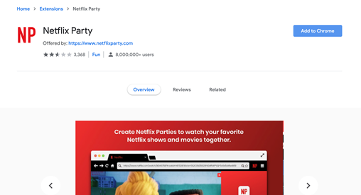

4. Another box will pop up asking you "Add Netflix Party?"  Click "Add Extension" as per pic below.

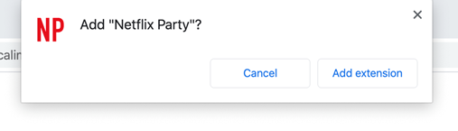

5.  You should now see a "NP" to the right of your search bar at the top of Chrome.  You're good!

6.  You will have until Saturday at 11am to make your movie selection by either emailing me or using the Poll created on our Special Olympics Sarnia Facebook account - I will tally the results.

7.  I will send you a link to the Netflix Party Saturday around 6pm (ish).  MAKE SURE YOU ARE USING GOOGLE CHROME and click on this link to start watching the Movie!!

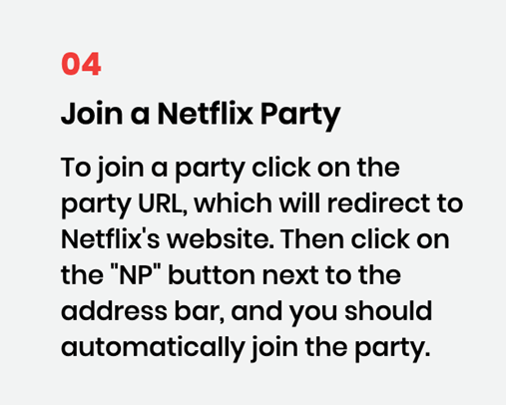

Make sure you have snacks ready by (Time)pm sharp - this is when the movie will start!  You will see a chat window to the right of the movie - feel free to say hello and comment during the movie!  We would love to hear from all of you!!!

Thanks everyone!  Send those votes in!!!